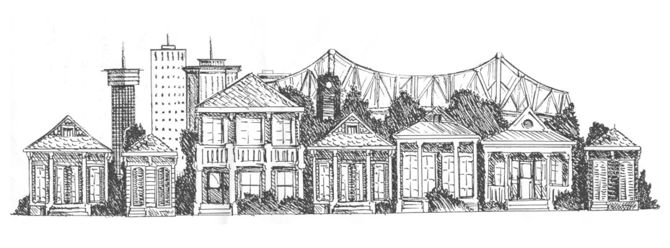
ALGIERS POINT ASSOCIATION MEMBERSHIP APPLICATION
Thanks for joining the APA!

First Name _________________________ Last Name ____________________________
First Name _________________________ Last Name ____________________________

Street Address _________________________________________________________ _________________________________________________________

Phone Number _________________________________________________________

E-Mail Address _________________________________________________________

Are you a resident of Algiers Point (owner or renter)? Please circle one: Yes No

Do you own a business in Algiers Point? Please circle one: Yes No

Comments:

